CBIIT Platform Independent Model and Service Specification

Lab Result Service

0.003

10 March 2011

Authors | Naveen Amiruddin
Editor | Naveen Amiruddin
Reviewers | Jennifer Brush
Template Version | 3.0

Version Number | Date | Contributor | Description
0.001 | 10 Jan. 2011 | Naveen Amiruddin | Initial Draft
0.002 | 12 Feb 2011 | Jennifer Brush | Review comments
0.003 | 10 March 2011 | Naveen Amiruddin | ESST Review
TABLE OF CONTENTS
1 Overview 4
1.1 Service Description and Purpose 4
1.2 Scope 4
1.3 Referenced Standards 4
1.4 Relationship to the Lab Result service Computational Independent Model Service Specification 4
1.4.1 Conformance and Compliance 5
1.4.2 Deviations 5
2 Platform Independent Model 6
2.1 Overview 6
2.2 Assumptions 6
2.3 Information model 6
2.3.1 Lab Result Service : Input/Output model 6
2.3.1.1 BRIDG Model 6
2.3.1.2 HL7v3 model 8
2.3.1.3 delete Input model 8
2.3.2 Error Information Model 8
2.3.3 Control Data Type Definitions 9
2.3.3.1 Status/Return Values/Exceptions 9
2.3.3.2 Error Codes 9
2.3.3.3 Query Parameters and Result Sets 9
2.4 Interface Model 10
2.4.1 UML Model of Interfaces 10
2.4.2 List of Operations (Enumeration) 10
2.4.3 Operation Behavior Descriptions 11
2.4.3.1 LabResultHL7v3ManagementService 11
2.4.3.2 LabResultBRIDGManagementService 13
3 Dynamic Model 16
3.1 Relationship with other services 16
4 Non Functional Requirements 17
4.1 Jurisdictional Domains 17
4.2 Auditing 17
4.3 Privacy 17
4.4 Additional Security Considerations 17
4.5 Deployment Considerations 18
5 Conformance Statements 19
5.1 Conformance Statements 19
6 Appendix A - References 21
7 Appendix B - Glossary 21
8 Appendix C - Cross Reference Tables 21
8.1 Interface to Profile Mapping 21
8.2 Interface Operations to Profile Operations 22

Lab Results Service Platform Independent Model and Service Specification

Overview

Service Description and Purpose
The purpose of this service is to provide a set of interfaces that enable creation, retrieval and deletion of Lab Data in the Clinical Trial Management Suite (CTMS) for a given Study and a Subject. This service will be used by various lab systems such as Laboratory Information Management System (LIMS) to create labs in the Clinical Trial Object Data System (CTODS). Other application such as the Cancer Adverse Event Reporting System (caAERS) and the Cancer Central Clinical Database (C3D) will use the get service capability to retrieve labs for a given Study and Subject. The out of range labs are critical to caAERS for Adverse Event Reporting.

Scope
Lab Result Service (LRS) provides a task service interface for managing Lab data for registered studies. This service will be consumed by Laboratory systems in order to load labs when it receives lab data for a given subject.
Below is a list of functions the LRS will provide:
- Create labs for a given Study and a Subject.
- Perform a query to retrieve a list of all labs for a given Study and a Subject.
- Delete labs for a given Study and a subject.

Referenced Standards

Standards | Description
BRIDG v3.0.1 | BRIDG model

Relationship to the Lab Result service Computational Independent Model Service Specification

Computational Independent Model and Service Specification Name | Computational Independent Model and Service Specification Version | Description & Link to the Computational Independent Model and Service Specification
Lab Result Service Computational Independent Model and Service Specification | 0.003 | https://ncisvn.nci.nih.gov/svn/ctodslabviewer/trunk/Documentation/service%20specs/Lab_Result_Service_cimss.doc

Conformance and Compliance
Conformance Profile No. | LR-CP1
Conformance Profile Name | Lab Results BRIDG Conformance Profile
Functional Profiles
  Functional Profile No. | Functional Profile Name
  LR-FP1 | Lab Results Functional profile
Semantic Profiles
  Semantic Profile No. | Semantic Profile Name
  LR-SP1 | Lab Results Analysis Model

Conformance Profile No. | LR-CP2
Conformance Profile Name | Lab Results HL7v3 Conformance Profile
Functional Profiles
  Functional Profile No. | Functional Profile Name
  LR-FP1 | Lab Results Functional profile
Semantic Profiles
  Semantic Profile No. | Semantic Profile Name
  LR-SP2 | HL7v3 CT Lab message

Deviations

Deviation from the Computational Independent Service Specification | Reason for Deviation
None | N/A

Platform Independent Model

Overview

Assumptions

Assumptions | Affects
Audit & Logging is assumed to be handled by supporting infrastructure | As a result it is not explicitly referenced in individual operations and assumed to be done automatically
Authorization checks are enforced. The user must be authenticated and should be authorized. The user must be associated to Lab Data User role to access get/create and delete capabalitied. | Only authorized users will be allowed access

Information model

Lab Result Service : Input/Output model
The Lab Result Service currently supports two semantic profiles to create/retrieve labs data to support multiple clients. The clinical systems are envisioned to use HL7v3 format messages and caBIG systems are envisioned to use a BRIDG-based model.

BRIDG Model

create/get model
The information model illustrated below shows the semantics of the service interface for create operation
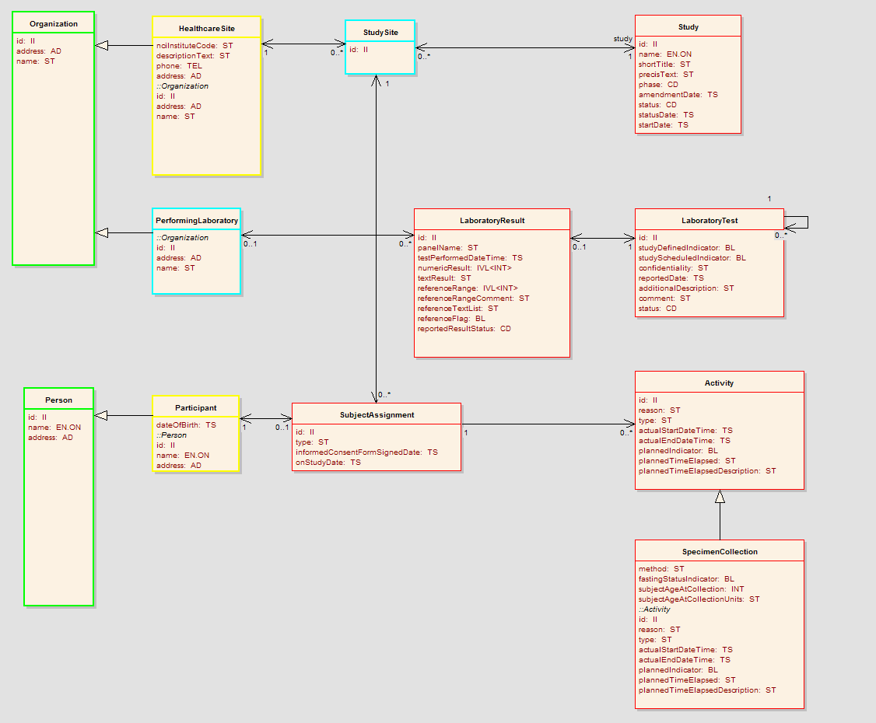

Figure 1 – BRIDG based model for lab create/get message

HL7v3 model

create/get model

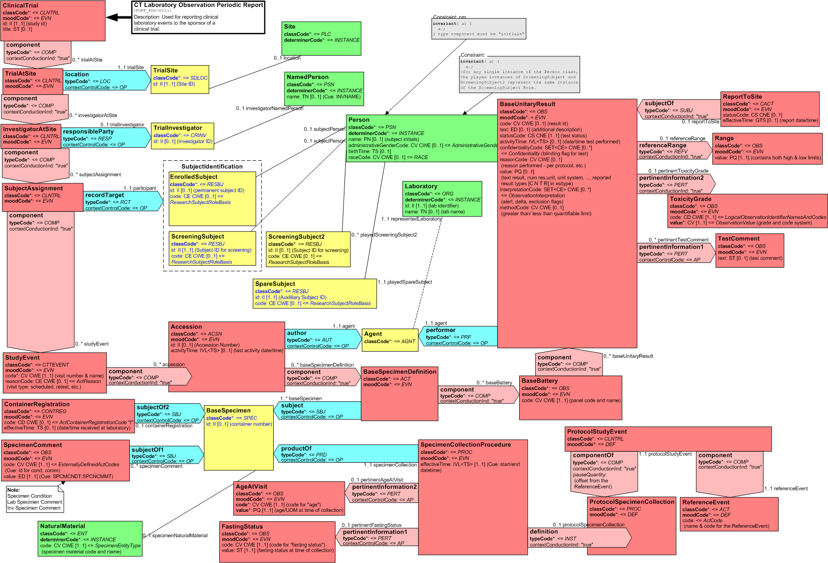

Figure 2 – the HL7 CT Lab message RMIM (Refined Message Information model).

Error Information Model
This service returns only one exception class named LRException. The structure and details of LRException class are given below

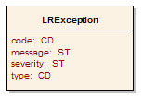
Figure 3 – Error Information Model

Attribute Name | Type | Attribute Description
Code | CD | The actual error code which the Exception class represents
Message | CD | The detailed error message
Severity | CD | The severity of this error. It can be “FATAL”, “HIGH”, “MEDIUM” or “LOW”
Type | CD | Indicates what type of error has occurred. Eg. Business, System etc.

Control Data Type Definitions
This service does not utilize any control data types.

Status/Return Values/Exceptions
Data Type | Type (Status / Return Value / Exception) | Data Type Description
LaboratoryResult | Return value | Returned by all get operations that transmit lab data to the caller; see section Error: Reference source not found.
LRException | Exception | The return object in case there is any exception during the execution of any of the operations listed below

Error Codes
Error Code | Error Type | Error Severity | Error/Exception Message
LR1001 | Business | HIGH | Invalid data type or code value for an attribute
LR1002 | Business | HIGH | User doesn’t have authorization for the Site
LR1003 | Business | HIGH | User doesn’t have authorization for the Study Protocol
LR1004 | Business | HIGH | User is not associated to Lab Data User role
SR2001 | Business | LOW | Study Subject doesn’t exist for the given identifier
SR2002 | Business | LOW | Site doesn’t exist for the given identifier
SR2003 | Business | LOW | Study doesn’t exist for the given identifier

Query Parameters and Result Sets
Data Type | Type (Query Search Criteria / Search Result Limiter / Query Result Set) | Data Type Description
N/A | N/A | This service does not use any search control data types.

Interface Model

UML Model of Interfaces
Interface No | Interface Name | Interface Description
LRMS-INF1 | LRHL7v3ManagementService | Provides functionality to manage labs for a Study and Site using HL7v3 RMIM message based payload.
LRMS-INF2 | LRBRIDGManagementService | Provides functionality to manage labs for a Study and Site using BRIDG based message payload.

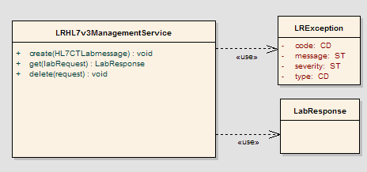

Figure 3 : LRHL7v3 Management Service Interface diagram

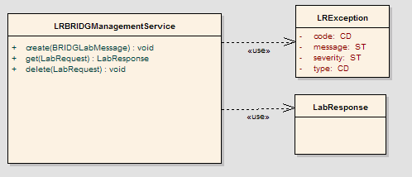

Figure 4 : LRBRIDG Management Service Interface diagram

List of Operations (Enumeration)

Operation No. | Operation Name | Interface Name | Operation Description
LRMS-INF1-OP1 | create | LabResultHL7v3ManagementService | Create a new lab for a study from a HL7v3 message.
LRMS-INF1-OP2 | get | LabResultHL7v3ManagementService | Retrieves the labs in a HL7v3 format for a study and site.
LRMS-INF1-OP3 | delete | LabResultHL7v3ManagementService | Delete labs for a study and site.

Operation No. | Operation Name | Interface Name | Operation Description
LRMS-INF2-OP1 | create | LabResultRBRIDGManagementService | Create a new lab for a study from a BRIDG message.
LRMS-INF2-OP2 | get | LabResultRBRIDGManagementService | Retrieves the labs in a BRIDG format for a study and site.
LRMS-INF2-OP3 | delete | LabResultRBRIDGManagementService | Delete labs for a study and site.

Operation Behavior Descriptions

LabResultHL7v3ManagementService

create
Corresponds to Submit a new Lab Result for a Study in the CIM.

create(HL7CTLabMessage) : hl7v3 xml message

Behavior Description | Create a new lab data and all its associations such as Site, Lab results, Subject Assignment, Activity, Organization and Person. The site can reference existing person, organization, and correlation records by ID or can create new records as needed.
Pre-Conditions | - None
Security Conditions | - The user must be associated to Lab Data User role.  - The user must be authorized to register trials and site
Inputs | HL7v3 CT Lab Message.
Outputs | None, Exception is thrown in case of any error
Post-Conditions | - Lab message is persisted.
Exception Conditions | - Security conditions are not met  - Study does not exist  - Reference to existing Person, Organization, or Correlation could not be found
Additional Implementation Details
Notes

get
Corresponds to retrieve a list of labs for a Study and Site in the CIM.

get(StudyIdentifier , SiteIdentifier, SubjectIdentifier) : hl7v3LabResult[]

Behavior Description | Get the list of all Lab Results associated with a Study.
Pre-Conditions | - none
Security Conditions | - The user must be associated to Lab Data User role.  - The user must be authorized to register trials and site.
Inputs | - StudyIdentifier : II  - SiteIdentifier : II  - SubjectIdentifier : II
Outputs | HL7v3 CT Lab Message
Post-Conditions | None
Exception Conditions | - Security conditions are not met
Additional Implementation Details | - This capability return a void if lab is not found for a given identifier.
Notes | At least one of the identifier must be provided.  - When site and subject identifier not provided, it retrieves all the sites and subjects for a given study  - When subject identifier not provided, it retrieves all the subjects for a given study and site identifier  I

delete
Corresponds to delete a list of labs for a Study and Site in the CIM.

delete(StudyIdentifier , SiteIdentifier, SubjectIdentifier) : void

Behavior Description | Delete a list of all Lab Results associated with a Study and a subject
Pre-Conditions | - Study must exist  - Site identifier must exist.  - Subject identifier must exist
Security Conditions | - The user must be authenticated  - The user must be associated to Lab Data User role.
Inputs | - StudyIdentifier : II  - SiteIdentifier : II  - SubjectIdentifier : II
Outputs | None
Post-Conditions | Deletes all the labs.
Exception Conditions | - Security conditions are not met.  - Study, site and subject must not be null.
Additional Implementation Details
Notes

LabResultBRIDGManagementService

create
Corresponds to Submit a new Lab Result for a Study in the CIM.

create(BRIDGLabMessage) : bridg xml message

Behavior Description | Create a new lab data and all its associations such as Site, Lab results, Subject Assignment, Activity, Organization and Person. The site can reference existing person, organization, and correlation records by ID or can create new records as needed.
Pre-Conditions | - None
Security Conditions | - The user must be associated to Lab Data User role.  - The user must be authorized to register trials and site.
Inputs | BRIDG laboratory message request.
Outputs | None, Exception is thrown in case of any error
Post-Conditions | - Lab message is persisted.
Exception Conditions | - Security conditions are not met  - Study does not exist  - Reference to existing Person, Organization, or Correlation could not be found
Additional Implementation Details
Notes

get
Corresponds to retrieve a list of labs for a Study and Site in the CIM.

getLabs(StudyII , SiteII, SubjectII) : labResult[]

Behavior Description | Get the list of all Lab Results associated with a Study.
Pre-Conditions | - Study exists
Security Conditions | - The user must be authenticated  - The user must be authorized to retrieve study & site information
Inputs | - Study identifier  - Site identifier  - Subject identifier
Outputs | The output of this operation is an array of the Lab Results described in section Error: Reference source not found or an empty array of the given Study has no labs.
Post-Conditions | None
Exception Conditions | - Security conditions are not met  - Study does not exist
Additional Implementation Details
Notes | At least one of the identifier must be provided.  - When site and subject identifier not provided, it retrieves all the sites and subjects for a given study  - When subject identifier not provided, it retrieves all the subjects for a given study and site identifier  I

delete
Corresponds to delete a list of labs for a Study and Site in the CIM.

delete(StudyIdentifier , SiteIdentifier, SubjectIdentifier) : void

Behavior Description | Delete a list of all Lab Results associated with a Study and a subject
Pre-Conditions | - Study must exist
Security Conditions | - The user must be authenticated  - The user must be authorized to delete lab message
Inputs | - Study identifier  - Site identifier  - Subject identifier
Outputs | None
Post-Conditions | Deletes all the labs (soft delete)
Exception Conditions | - Security conditions are not met  - Study, site and subject does not exist
Additional Implementation Details
Notes

Dynamic Model

Relationship with other services
Service Name | Producer / Consumer | Data | Description
Person Service | Producer | Person Information | This service relies on the Person service to either retrieve the person record as site contact or request creation of a new person record
Organization Service | Producer | Organization Information | This service relies on the Organization service to either retrieve the Organization
Protocol Service | Producer | Study/Protocol information | This service relies on the StudyProtocol service to allow submission of data for a specific instance of a StudyProtocol

Non Functional Requirements

Auditing

Operation Name | Auditing Details
Create | Logged in User  Time stamp of creation
Get | Logged in User
Delete | Logged in User  Time stamp of deletion

Privacy
Data Element | Privacy Regulation | Access Requirement | Public Information
Study and Site |  | User must have access to Study and Site.
 |  | User must be associated to Lab Data user roles.

Additional Security Considerations

Security Consideration | Description
Authentication | Service should accept only Level Of Assurance 1 credentials and above for authentication
Authorization | Service should employ a Role Based Authorization framework
Encryption | Service should transmit data over an encrypted channel

Deployment Considerations
Deployment Consideration | Impact
Local Deployment Mode | Service should be able to run locally in the same container as the client application
Remote Deployment Mode | Service should run remotely and be able to support remote client
Scalability | Service should be able to serve 100 users simultaneously
Up time | Service should have a 99.9 % uptime
Failover | Given up time considerations, service does not need to have a hot fail over

Conformance Statements

Conformance Statements

No. | Name | Type | Compliance Profile | Viewpoint | Description | Test method
CS1 | Query Performance | Obligation | Lab Results Data | Engineering | The query for retrieving all participating sites for a given study protocol should return in less than 3 seconds | 1. Test cases to include performance testing.
CS2 | Conformance Profiles | Obligation | Lab Results Data | Computational / Information | In order to claim a minimal level of conformance to the specification, designers/implementers are obligated to support the either one Conformance Profiles or all of the conformance profile. | 1. Test cases to be defined to test each specified profile
CS3 | ISO Datatypes | Obligation | Lab Results Data | Information | Designers/implementers are obliged to support the ISO 21090 datatypes in all operations | 1. Test cases to include processing of each relevant data type
CS4 | Auditing | Obligation | Lab Results Data | Engineering | Designers/implementers are obligated to decide on and document the approach for logging or auditing of the operation calls. | 1. Design Review
CS5 | Operation Behavior Issues / Assumptions | Obligation | Lab Results Data | Computational / Information / Engineering | Architects/Designers/Developers are obligated to confirm (or refute) all Assumptions made in the Notes for the Service Realization sections of each operation and the overall Assumptions section. | 1. Design Review

Appendix A - References

Name | Description | Location
BRIDG v 3.1 | BRIDG model used for modeling the Lab Result Management Service | http://gforge.nci.nih.gov/frs/?group_id=342

Appendix B - Glossary
Term | Description
BRIDG | The Biomedical Research Integrated Domain Group (BRIDG) has developed a comprehensive domain analysis model representing protocol-driven preclinical and clinical research.
CP | Conformance Profile
FP | Functional Profile
LDS | Lab Data Service
SP | Semantic Profile
CTMS | Clinical Trial Management Suite
LRS | Lab Result Service
LIMS | Laboratory Information Management System
caAERS | Cancer Adverse Event Reporting System
C3D | Cancer Central Clinical Database
CTODS | Clinical Trial Object Data Systems

Appendix C - Cross Reference Tables

Interface to Profile Mapping

Interface No. | Interface | Profile No. | Profile
LRMS-INF1 | LabResultHL7v3ManagementService | LR-FP1 | Lab Results Service
LRMS-INF2 | LabResultRBRIDGManagementService | LR-FP1 | Lab Results Service

Interface Operations to Profile Operations

Operation No. | Operation Name | Capability No. | Profile Capability
LRMS-INF1-OP1 | Create | LR-CPB1 | Add a Lab to a Study
LRMS-INF1-OP2 | Get | LR-CPB2 | Retrieve a list of all labs for a Study and subject
LRMS-INF1-OP3 | Delete | LR-CPB3 | Deletes a list of all labs for a Study and subject
LRMS-INF2-OP1 | Create | LR-CPB1 | Add a Lab to a Study
LRMS-INF2-OP2 | Get | LR-CPB2 | Retrieve a list of all labs for a Study and subject
LRMS-INF2-OP3 | Delete | LR-CPB3 | Deletes a list of all labs for a Study and subject

